Mini Project
End- to- End Data Pipeline: Blob Storage - Azure Data Factory - Destination
Week 4 Assignment Azure Cloud Fundamentals & ADF
Celebal Technologies Summer Internship 2026
Domain: Data Engineering
Submitted by: Kinshu Sachdeva
Date: 14 June 2026

Problem Statement
Build a complete pipeline that reads a CSV file from Blob Storage and processes it using Azure Data Factory.
Requirements
- Source: CSV file stored in Azure Blob Storage.
- Use: Linked Service + Dataset + Pipeline.
- Process: Copy Data activity together with a Metadata check.
- Destination: new file / location.
Expected Output
- Pipeline executed successfully.
- Data copied to the destination.
- Metadata validated.
Solution Overview
In order to meet these criteria, a complete end- to- end was developed using Microsoft Azure. This involves provisioning the required cloud resources (resource group & storage), loading the source CSV, creation of the Azure Data Factory, and connecting all the required components through a linked service and datasets. The process starts with validation of the source file through a Get Metadata activity, which is then followed by the movement of data into a destination file through a Copy Data activity.
Resources Used
- Resource Group: Celebal_Week_4 (Region: Central India)
- Storage Account: week4blobstorage07 (Standard, LRS)
- Containers: source (input) and destination (output)
- Data Factory: week4- Kinshu
- Linked Service: ls_blob_source
- Datasets: ds_source_csv (source), ds_dest_csv (destination)
- Pipeline: pl_copy_superstore
- Dataset file: Sample Superstore.csv

Step 1 Create the Resource Group
A Resource Group is a logical container that holds all the resources for the project, allowing them to be managed and deleted together.
Action
- In the Azure Portal, navigated to Resource groups and clicked Create.
- Named the resource group Celebal_Week_4, selected the subscription, and chose Central India as the region.
- Reviewed and created the resource group.
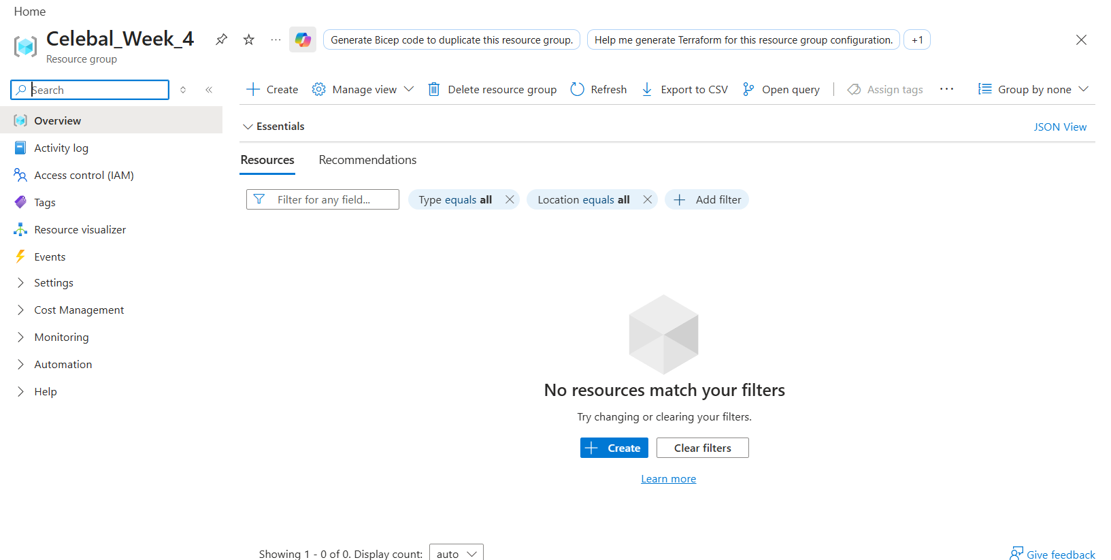
Figure 1 Resource Group 'Celebal_Week_4' created successfully.

Step 2 Create the Storage Account and Containers
A Storage Account hosts the Blob containers that hold the source and destination files.
Action
- Storage Account named week4blobstorage07 (performance: standard, redundancy: locally-redundant storage/LRS) was created in Celebal_Week_4 resource group, where the main service has been set up as Azure Blob Storage.
- After deployment, opened the storage account and, under Data storage - Containers, created two containers: source (for the input CSV) and destination (for the pipeline output).
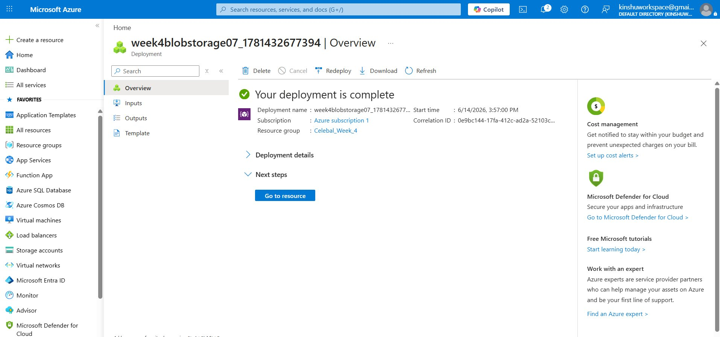
Figure 2 Storage Account 'week4blobstorage07' deployed successfully in resource group Celebal_Week_4.
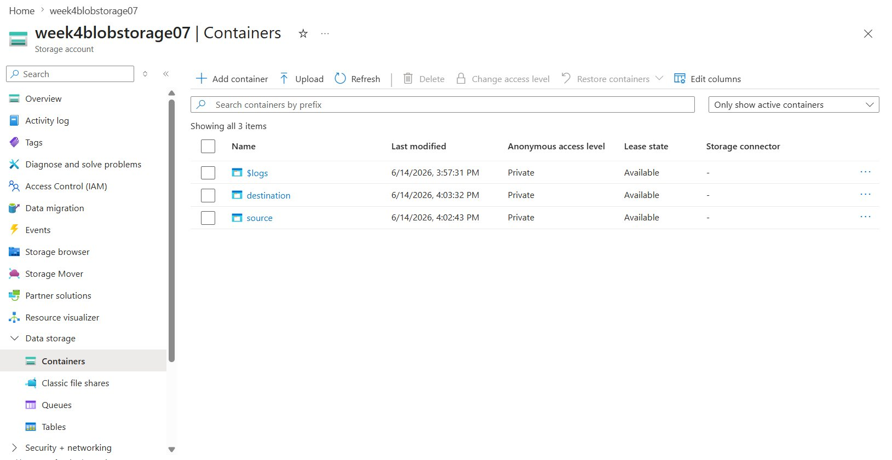
Figure 3 Containers 'source' and 'destination' created in the storage account.
Step 3 Upload the Source CSV File
The source CSV is the input that the pipeline will read from Blob Storage.
Action
- Opened the source container and uploaded the Sample Superstore.csv file.
- Verified the file appears in the container, confirming the source data is in place.
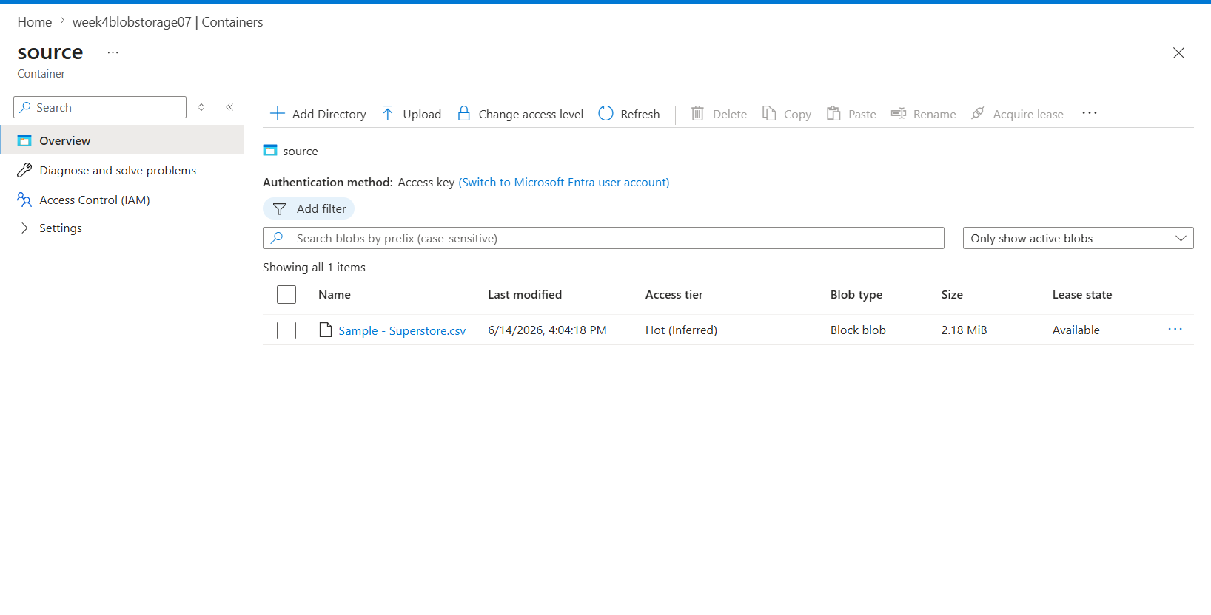
Figure 4 'source' container with the uploaded Sample Superstore.csv file (Source requirement).

Step 4 Deploy Azure Data Factory
Azure Data Factory (ADF) is the orchestration service used to build and run the pipeline.
Action
- Created an Azure Data Factory named week4- Kinshu inside the resource group.
- Launched Azure Data Factory Studio and explored its three main hubs: Author (build pipelines and datasets), Monitor (view pipeline runs), and Manage (linked services and triggers).
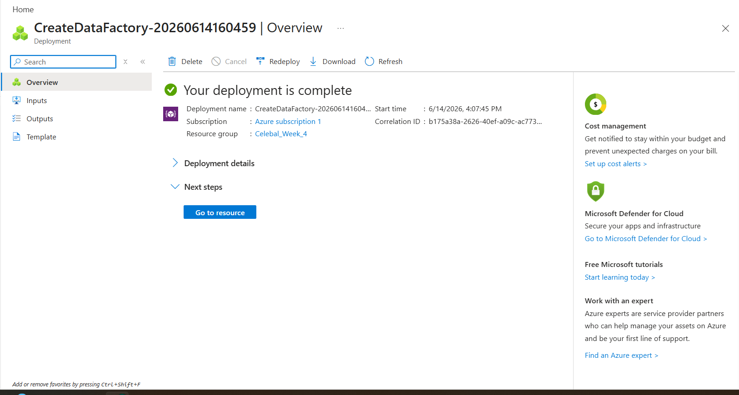
Figure 5 Azure Data Factory deployed successfully.
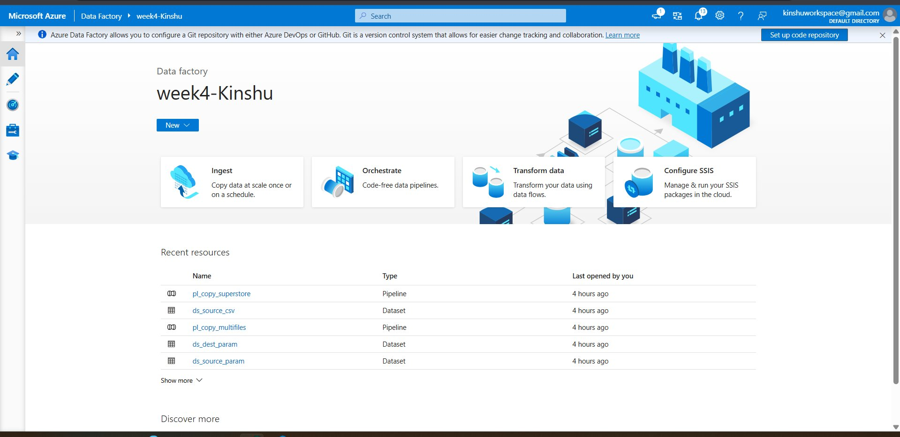
Figure 6 Azure Data Factory Studio (week4- Kinshu) showing the Ingest, Orchestrate and Transform options and the Author/Monitor/Manage hubs.
Step 5 Create the Linked Service
A Linked Service stores the connection information that allows ADF to communicate with the Blob Storage account.
Action
- In Manage - Linked services, created an Azure Blob Storage linked service named ls_blob_source using account- key authentication.
- Ran Test connection, which returned success, then created the linked service.
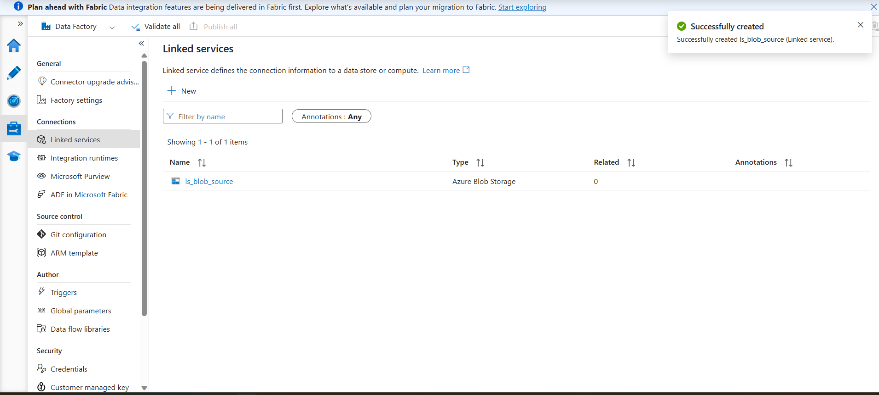
Figure 7 Linked Service 'ls_blob_source' (Azure Blob Storage) created (Linked Service requirement).

Step 6 Create the Datasets
Datasets define the shape and location of the data. A source dataset points to the input CSV, and a destination dataset points to the output location.
Action
- Created a source dataset (ds_source_csv) of type DelimitedText pointing to Sample Superstore.csv in the source container, with 'First row as header' enabled.
- Created a destination dataset (ds_dest_csv) of type DelimitedText pointing to Superstore_output.csv in the dataset container
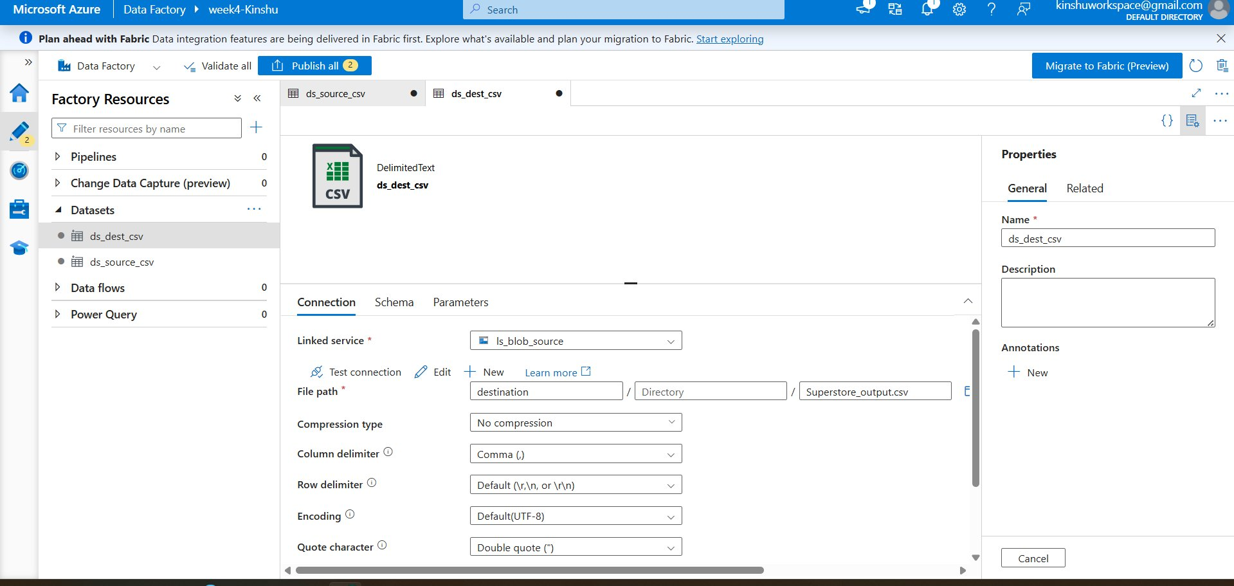
Figure 8 Dataset configuration (DelimitedText / CSV).

Step 7 Add the Get Metadata Activity (Metadata Check)
The Get Metadata activity validates the source file before it is copied, satisfying the metadata- check requirement.
Action
- Created a pipeline named pl_copy_superstore.
- Added a Get Metadata activity referencing the source dataset ds_source_csv.
- Configured its field list to return Item name, Size, and Column count, so the file's metadata is validated at run time.
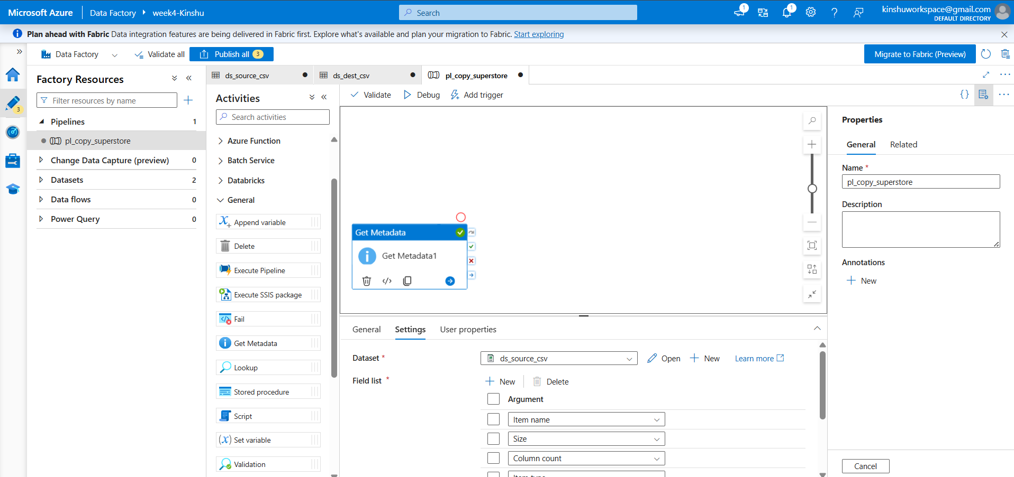
Figure 9 Get Metadata activity with field list (Item name, Size, Column count) Metadata check requirement.

Step 8 Add the Copy Data Activity and Build the Pipeline
The Copy Data activity performs the actual transfer of data from the source to the destination, satisfying the Copy Data requirement.
Action
- Added a Copy data activity after Get Metadata and connected the green 'on success' output of Get Metadata to it, so the copy runs only after metadata validation succeeds.
- Configured the Copy data Source to ds_source_csv and the Sink to ds_dest_csv.
- Validated the pipeline no errors were found.
Figure 10 Complete pipeline design: Get Metadata - Copy data (validated, no errors found).

Step 9 Execute the Pipeline
Running the pipeline executes the metadata check and the copy operation end to end.
Action
- Published all changes to the Data Factory service.
- Ran the pipeline using Debug and monitored the Output tab.
- Confirmed that both the Get Metadata and Copy data activities completed with status Succeeded.
Figure 11 Pipeline executed successfully (Pipeline status: Succeeded) Pipeline executed successfully requirement.

Step 10 Verify the Output at the Destination
Finally, the destination container is checked to confirm the data was copied to a new file, satisfying the Destination and data- copied requirements.
Action
- Opened the destination container in the storage account.
- Confirmed that the new output file (Superstore_output.csv, 2.18 MiB) was created, proving the data was copied end to end (Blob - ADF - Blob).
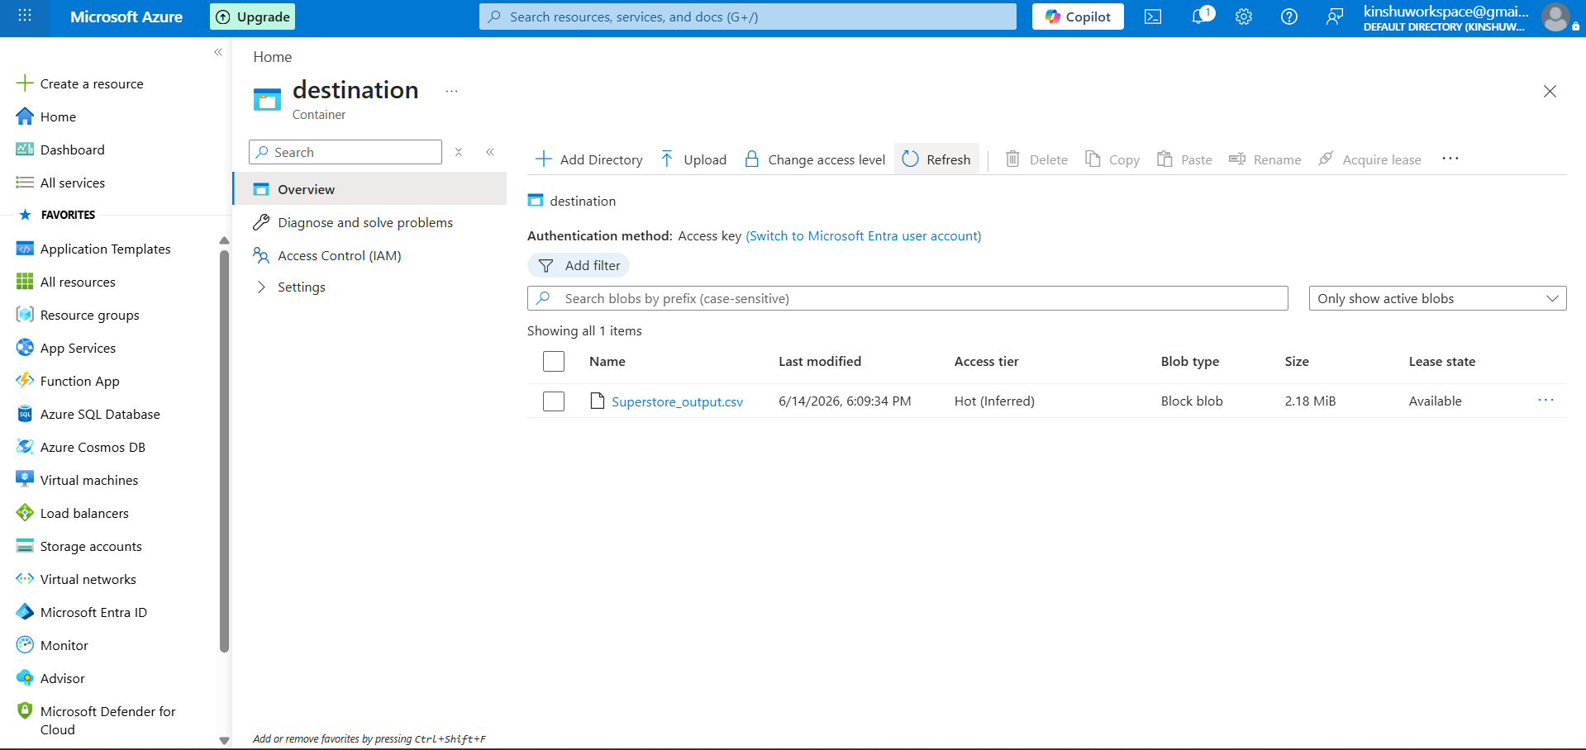
Figure 12 Destination container showing the copied output file (Destination + Data copied requirements).

Requirement Verification
In this part, each Mini Project requirement is mapped to its respective implementation in the existing build.
Requirements met
- Source (CSV in Blob): Sample Superstore.csv in the 'source' container Figure 4.
- Linked Service: ls_blob_source Figure 7.
- Dataset: ds_source_csv and ds_dest_csv Figure 8.
- Pipeline: pl_copy_superstore Figure 10.
- Process (Copy Data + Metadata check): Get Metadata - Copy data Figures 9 and 10.
- Destination (new file/location): Superstore_output.csv in the 'destination' container Figure 12.
Output expected obtained
- Pipeline execution status: Successful execution (Figure 11).
- Data transfer: 2.18 MiB of data transferred to new destination file (Figure 12).
- Metadata verification: Item Name, Size, and Column Number verified (Figure 9).
Conclusion
The Mini Project was successfully completed. An end- to- end data pipeline is successfully implemented on Azure Data Factory where a CSV file is ingested from Blob Storage, metadata is verified by means of the Get Metadata activity, and finally, data copy operation is performed

